ALL PRODUCTS DATA
ONGRID INVERTERS

- ORI-(1/1.5/2/2.2/2.5/2.7/3/3.3/3.6/4)K-OG04P1-EU-CM1
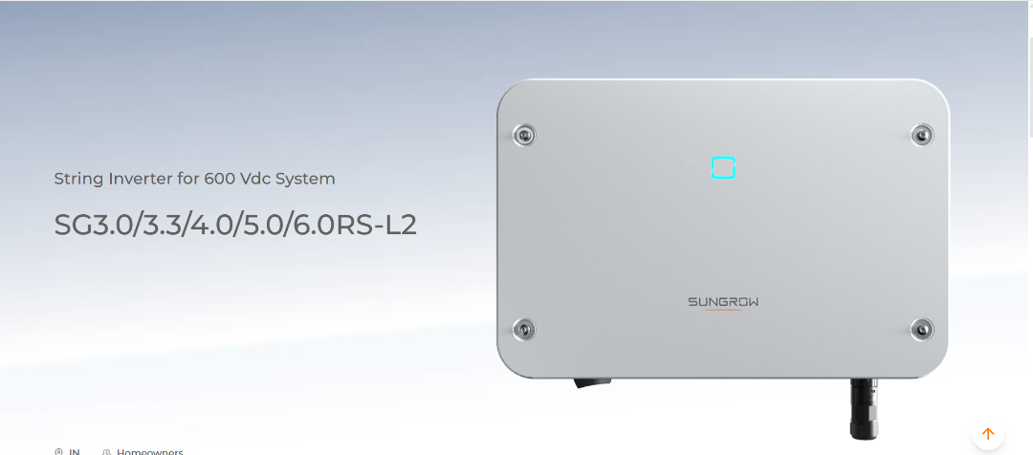

- Add Inverter photo and Model no same like this, background similar or likewise.
- Tech specs.-
Max. PV Input Voltage- 550 v
Rated AC Output Power- 1-4kW
Rated AC Voltage- 230v
Max. Efficiency- 97.3%
Features-
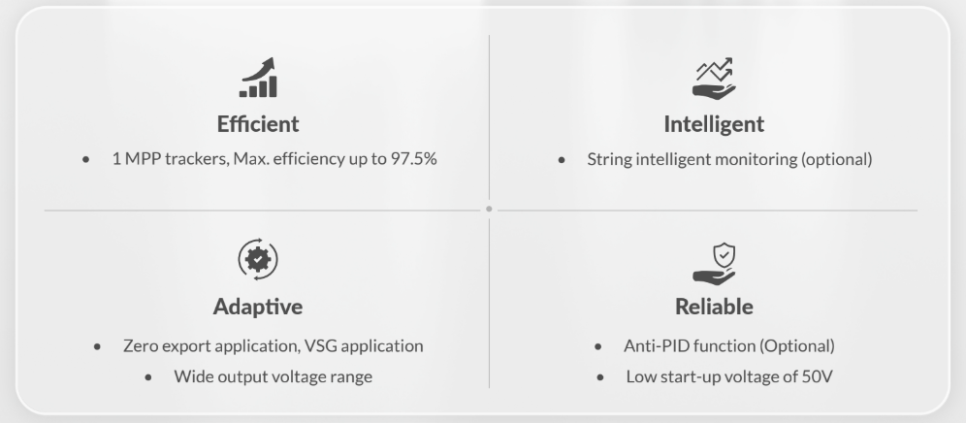

- ORI-(3.6/4/4.2/4.6/5/5.2/6/6.2)K-OG05P1-EU-CM2
- Tech specs.-
Max. PV Input Voltage- 550 v
Rated AC Output Power- 3.6-6.2kW
Rated AC Voltage- 230v
Max. Efficiency- 97.5%
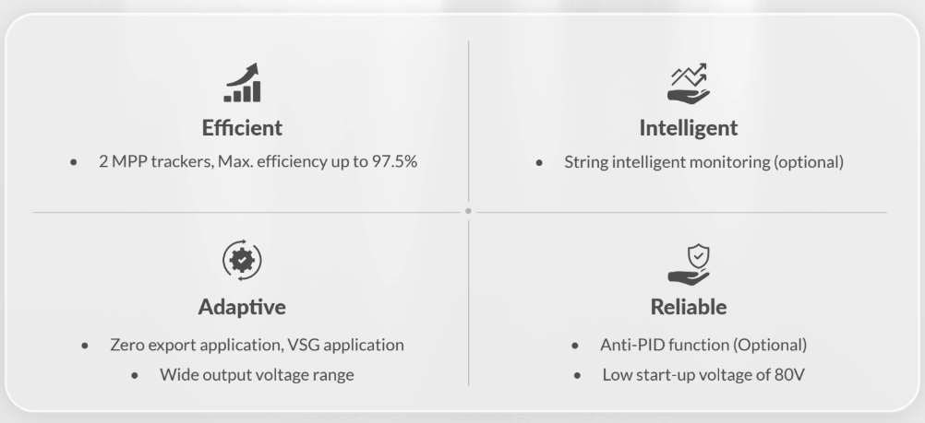

- ORI-(5/6/7/8/9/10/12/15)K-OG06P3-EU-CM2-P1
- Tech specs.-
Max. PV Input Voltage- 1100 v
Rated AC Output Power- 5-15kW
Rated AC Voltage- 415-440v
Max. Efficiency- 98.5%
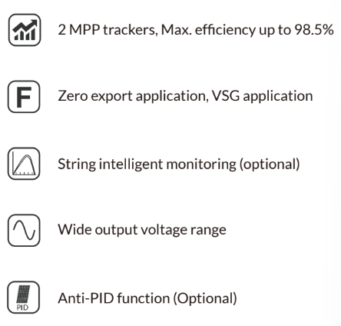

- ORI-(18/20/25)K-OG05
- Tech specs.-
Max. PV Input Voltage- 1100 v
Rated AC Output Power- 18-25kW
Rated AC Voltage- 415-440v
Max. Efficiency- 98.5%
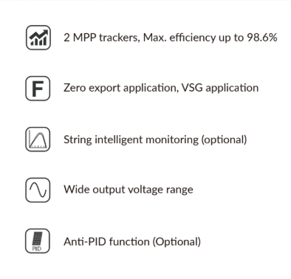

- ORI-(30/33/35/36)K-OG04P3-EU-CM2
- Tech specs.-
Max. PV Input Voltage- 1100 v
Rated AC Output Power- 33-36kW
Rated AC Voltage- 415-440v
Max. Efficiency- 98.6%
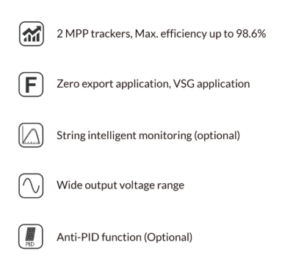

- ORI-(40/45)K-OG04P3-EU-CM3, ORI-50K-OG04P3-EU-CM4
- Tech specs.-
Max. PV Input Voltage- 800 v
Rated AC Output Power- 40-50kW
Rated AC Voltage- 415-440v
Max. Efficiency- 98.7%
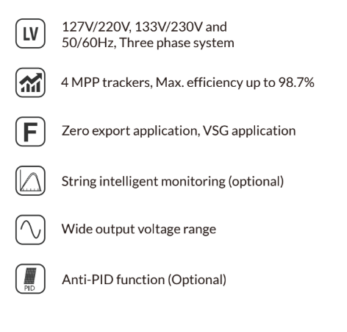

- ORI-(60/70/75/80)K-OG04P3-EU-AM4
- Tech specs.-
Max. PV Input Voltage- 1100 v
Rated AC Output Power- 60-80kW
Rated AC Voltage- 415-440v
Max. Efficiency- 98.7%
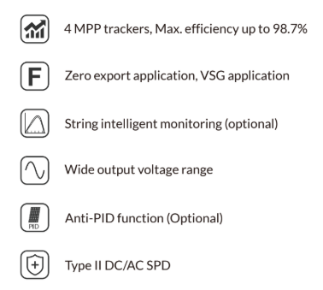

- ORI-(70/75/80/90/100/110)K-OG03
- Tech specs.-
Max. PV Input Voltage- 1000 v
Rated AC Output Power- 70-110kW
Rated AC Voltage- 415-440v
Max. Efficiency- 98.8%
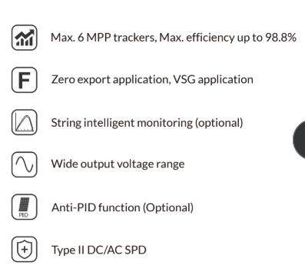

- ORI-(120/125/130/135/136)K-OG01P3-EU-AM8
- Tech specs.-
Max. PV Input Voltage- 1100 v
Rated AC Output Power- 120-136kW
Rated AC Voltage- 415-440v
Max. Efficiency- 98.8%
